Class 3 Long Term Planning
 | Autumn – Cycle A | Spring – Cycle A | Summer – Cycle A | Autumn – Cycle B | Spring – Cycle B | Summer – Cycle B
 | Towers, tunnels and turrets  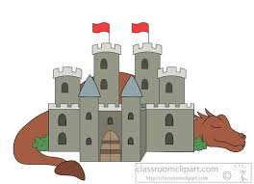 | Cavemen  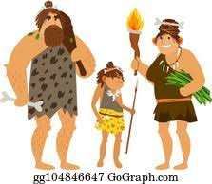 | Revolting Romans  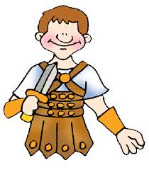 | Location, Location, Location  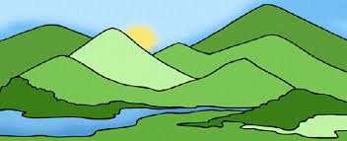 | Tomb Raiders  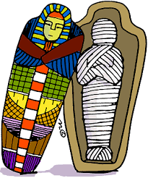 | Into Africa – Lion king  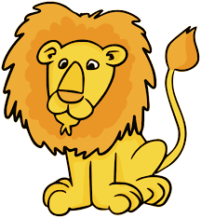
English | Traditional Tales The Princess and the Pea  Information texts:  Dragon Poems inspired by Tell Me A Dragon  Alternative fairytales: George and the Dragon | Adventure stories: Stone Age Boy  Instructions: How to Wash a Woolly Mammoth  Information texts:  Playscripts | Explanation texts: Lifecycles  Stories in historical settings:  Roman myths, Hercules  Ocean/ sea poems | Autumn poetry  Legends: Blue John  Formal letters:  Traditional tales: Hansel and Gretel, | News reports:  The Three Little Pigs  The Egyptian Cinderella  Explanation texts | Giraffes Can’t Dance  Biographies:  African animal poetry  Tinga Tinga Tales
History | Normans and the Norman invasion  Features of a Norman castle  Ludlow castle  Castle defences  Castle life  William the Conqueror, King Harold II  Trip to Ludlow castle | Stone Age to Iron Age  Cave paintings  Skara Brae  Hill forts  Stonehenge  Trip to Secret Hills Discovery centre | Spread of the Roman Empire  Roman invasion of Britain  Boudicca’s rebellion  Hadrian’s wall  Roman roads  Roman baths  Roman gods and goddesses  Julius Caesar, Boudicca | Clee Hill local study  Clee Hill Quarry  Mapskills  Mappa Mundi  How land use has changed over time | Who were the ancient Egyptians?  What was life like in ancient Egypt?  Mummification  Gods and goddesses  Hieroglyphics  Tutankhamun, Cleopatra, Howard Carter | The Kingdom of Benin  African tribes  Ancient Benin and ancient artefacts  Benin bronzes  The end of Benin  Apartheid and the life of Nelson Mandela
Geography | Compass directions  Local study- Ludlow  Mapskills  Reading miles: UK countries and capital cities  Using maps, atlases and globes to locate countries | Water, water everywhere  Dams, Elan Valley  Water supplies, Severn Trent  Weather patterns  Weather station | Oceans and seas  Continents  Great barrier reef  Lines of latitude, longitude and the equator | Local area study  Mapskills, mapping local area  Compass directions  Local amenities  Contrasting localities Clee Hill/ reading miles  Reading miles: continents, oceans, using maps, globes and atlases to locate countries | Seasonal and daily weather patterns in UK and reading miles countries  Weather station  Caring for our world and the local environment | Africa as a continent and countries  Comparison with Clee Hill
Science | Uses of everyday materials  Light  Forces and magnets  Marie Curie | Animals including humans  Rocks  Mary Anning | Living things and their habitats  Plants  Ahmed Mumin Warfa, Joseph Banks | Rocks and Soils  Light  Dr Anjana Khatwa & James Clerk | Forces and Magnets  Famous scientist – Michael Faraday | Animals including humans  Plants  Famous scientist – Joseph Banks
DT | Pulleys, structures  Bridges and structures  Drawbridges and castles | Food- Healthy Wraps and Sandwiches  Combining ingredients | Pneumatics  Designing and making a moving ocean creature | Textiles – 2D to 3D  Sewing Animals | Levers and Linkages  Make a Shaduf. | Food- flatbreads  East African chapati
Art | Textiles, Bayeux tapestry  Faith Ringgold  Sculpture, dragon’s eyes | Charcoal  Cave paintings  Banksy | Mosaics  Jim Bachor | Landscapes – pencil and paint  Andy Goldsworthy  David Hockney | Sketching and painting Egyptian figures  Canopic jars from clay  Making paper  Clare Twomey | Sculpture, African masks  Silhouette pictures  Tie dye  Lois Malou Jones
Exploring Spirituality | Christianity, Islam, Hinduism  2.1 What do people believe about God? | Christianity, Islam, Hinduism  2.4 Why do people pray? | Judaism  1.3 What do Jewish people believe? | Hinduism  What does it mean to be a Hindu in Britain today? | Christianity, Judaism, Islam  1.4 What can we learn from sacred books? | 2.3 How and why do Hindus, Christians and Muslims see life as a journey?
PSHE and SRE | Relationships  Families and friendships  Safe relationships  Respecting ourselves and others | Living in the wider world  Belonging to a community  Media literacy and digital resilience  Money and work | Health and wellbeing  Physical health and mental wellbeing  Growing and changing  Keeping safe | Relationships  Families and friendships  Safe relationships  Respecting ourselves and others | Living in the wider world  Belonging to a community  Media literacy and digital resilience  Money and work | Health and wellbeing  Physical health and mental wellbeing  Growing and changing  Keeping safe
Computing | Purple Mash 2.2 Online safety  2.1 Coding  Sphero BOLTS | 3.2 Online safety  3.1 Coding  2.6 Creating pictures | 2.3 Spreadsheets  3.9 Presenting  3.6 Branching databases | Purple Mash 2.2 Online safety  2.1 Coding  Sphero BOLTS | 3.2 Online safety  3.1 Coding  2.8 Presenting ideas  Reading miles postcards | 3.8 Graphing  3.3 Spreadsheets  3.5 email  Sending an email to our link school in Tanzania
Music | Let your spirit fly  The dragon song | Three Little Birds  Glockenspiel Stage 1 | Bringing us together  Reflect, rewind and replay | Hands, feet, heart  Ho, Ho, Ho | I want to play in a band  Zoo time | Friendship song  Reflect, rewind and replay
MFL | Greetings  Alphabet | Numbers 1-10  Colours | Animals | Greetings  Alphabet | Numbers 1-10  Colours | Animals
PE | Forest schools weather station  Gymnastics  Netball | Dance  Tennis  Forest schools | Forest schools  Swimming  Athletics | Forest schools  Orienteering  Gymnastics | Forest schools  Dance  Netball | Forest schools  Swimming  Athletics
Enrichment Opportunities | Ludlow Castle  Castles celebration day | Shropshire Hills Discovery Centre  Elan valley | Wroxeter  Romans celebration day | Clee Hill Quarry | Ancient Egypt workshop Birmingham museum  Ancient Egyptians day | Safari park

