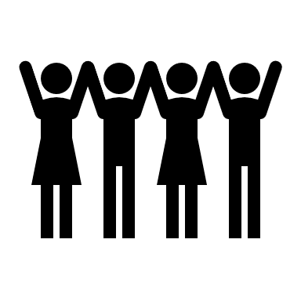

**LOVING AND CARING**

**CREATED**

**God**

**Christian** and **Jewish** people believe that **God** created the **world** and the people in it. They believe that God created people in His Image**.** People can read this story in the book of **Genesis** which is the first book in the **Christian** Old Testament and the first Book of Moses for **Jewish** people.

This means that everybody on earth is different and unique, and we are all part of the worldwide **community.** Everyone who is **religious** or **non-religious** believes we should take care of the world and everyone in it.

In the Bible and the Torah there are many stories and teachings about how we should take care for planet, which is known as **stewardship** and how we should show **love** for each by looking after everyone. In the book of **Psalms,** Jewish people are told how much God loves and cares for them and in the Gospels, Christians are taught that God loves and cares for them as well.

People want to show how much they love and care for each other and they do this through helping other people by giving help like Mother Teresa did or by giving tzedakah. Many Jewish people believe the festival of Sukkot is about helping others just as God helped the Jewish people when they left Egypt.

Community:a group of people who have something in common

World: the planet and everything and everyone in it

Psalm: a sacred song or hymn, often used in Christian and Jewish worship

Stewardship: the act of looking after and caring for something

Love: a strong feeling of affection or attachment to someone or something

Genesis: the first book of Moses for Jewish people and the first book of the Old Testament for Christians.

Religious: believing in a religion

Non-religious: not believing in a religion.

Christian: anything that is part of, or someone who follows Christianity.

Jewish: anything that is part of, or someone who follows Judaism.

Important information

So how does it all work?

Wonderful words

How should we care for the world and for others, and why does it matter?

Year One  
**Knowledge  
Organiser**

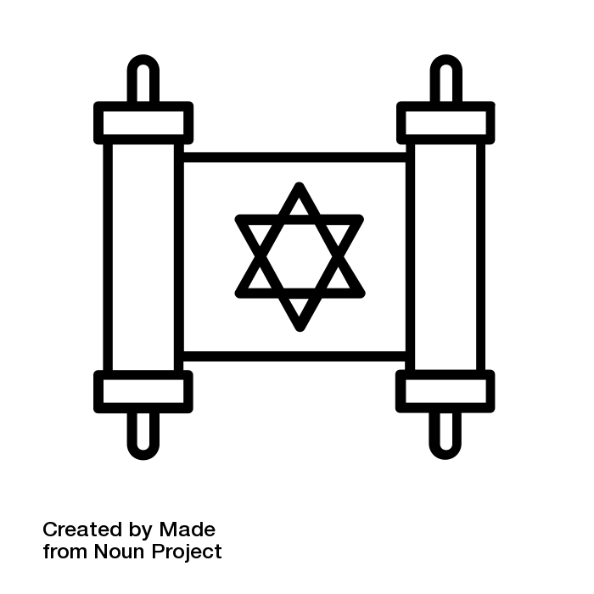



Year One – Knowledge Organiser

UNIT  
**12**